**LAB # 01**

**OBJECTIVE:**

• Understand the basics of deep learning and its applications.

• Set up the Python environment for deep learning.

• Perform basic operations using TensorFlow and Scikit-learn.

**LAB TASKS:**

* **TASK 1.**
* Create a TensorFlow tensor with random float values. Calculate the sum, mean, and maximum of the tensor. Hint: Use tf.reduce_sum(), tf.reduce_mean(), tf.reduce_max().

**CODE:**

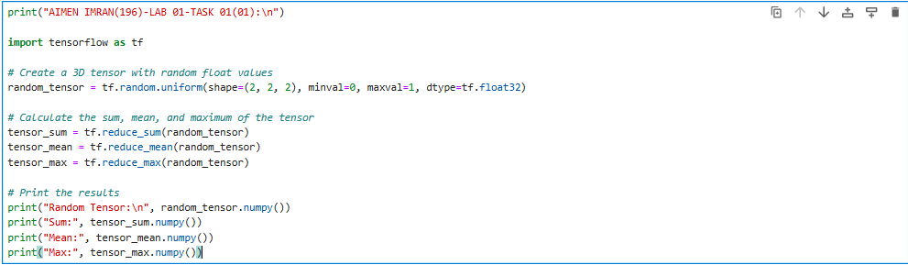

**OUTPUT:**

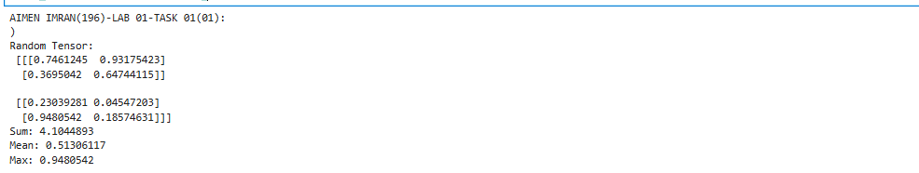

* Create a 3D TensorFlow tensor. Access and print a specific element, a 2D slice, and a 1D slice. Hint: Use standard Python indexing and slicing syntax.

**CODE:**

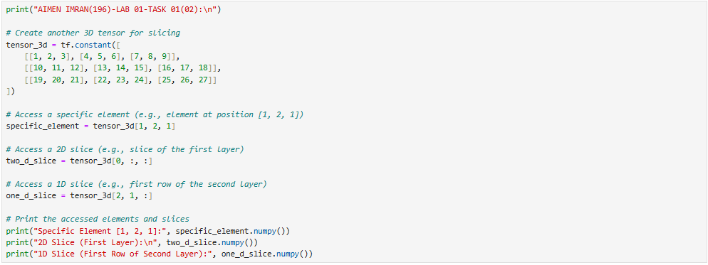

**OUTPUT:**

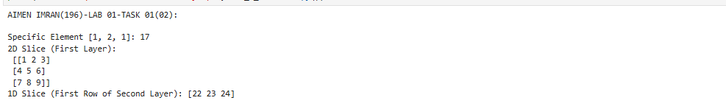

* **TASK 2**

Create a TensorFlow function called tensor operations that takes two tensors as input and performs the following arithmetic operations:

* Addition (tensor1 + tensor2)
* Subtraction (tensor1 - tensor2)
* Multiplication (tensor1 * tensor2)
* Division (tensor1 / tensor2)

The function should return the results of these operations as a dictionary with the following keys:

* "addition"
* "subtraction"
* "multiplication"
* "division"

**CODE:**

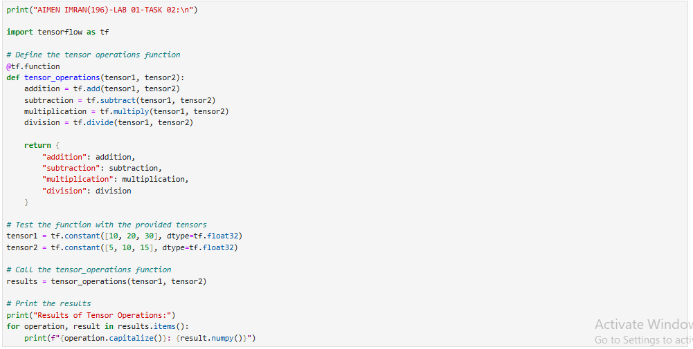

**OUTPUT:**

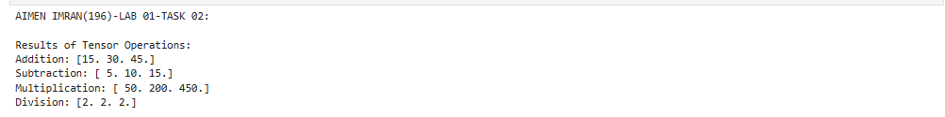

* **TASK 3.**

1. Create a NumPy array with random float values. Sort the array in ascending and descending order. Hint: Use np.sort() and array slicing. 2. Create a 2x2 NumPy matrix.

**CODE:**

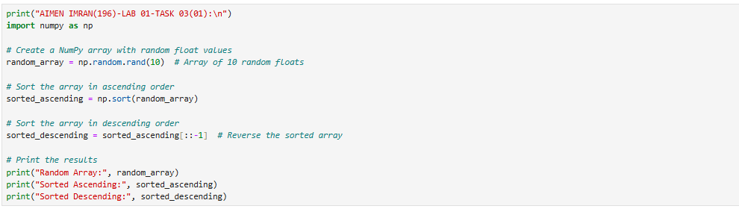

**OUTPUT:**

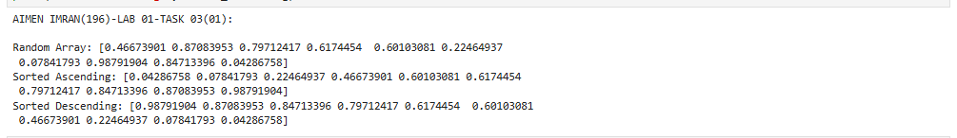

1. Calculate its transpose and inverse. Hint: Use np.transpose() and np.linalg.inv(). 3. Create a 2D NumPy array. Calculate the sum of each row, the mean of each column, and the standard deviation of the entire array.

**CODE:**

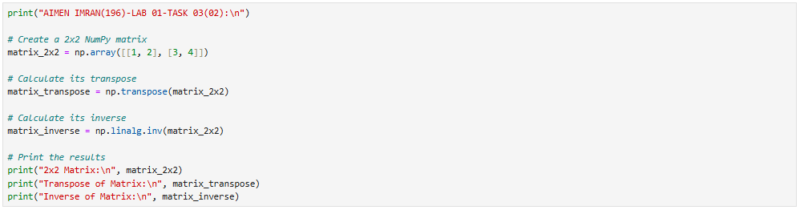

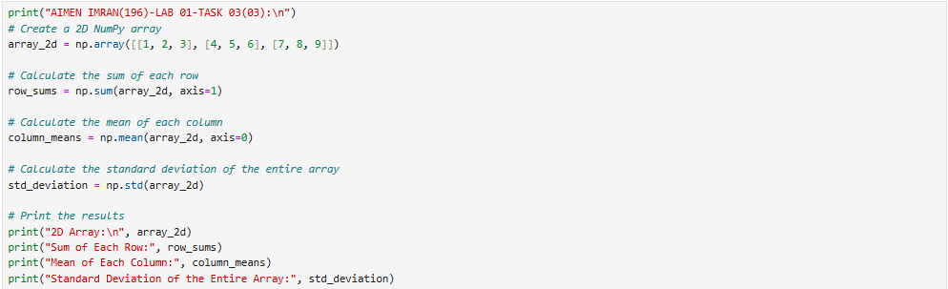

**OUTPUT:**

